Database Security Project 428
Project Management Plan


Department of Information Technology and Management
December 2021
Version 1.0

Artifact Rationale
The Project Management Plan (PMP), according to the Guide to the Project Management Body of Knowledge (PMBOK®), is a formal, approved document used to guide both project execution and project control. The primary uses of the PMP are to document planning assumptions and decisions, facilitate communication among stakeholders, and document approved scope, cost, and schedule baselines. By showing the major products, milestones, activities and resources required on the project, it is also a statement of how and when a project's objectives are to be achieved.
The project manager creates the PMP following input from the project team and key stakeholders. The plan should be agreed on and approved by at least the project team and its key stakeholders.
The PMP is mandatory for all projects. While it is a project-level document, it should be updated as necessary, including for each increment.
Table of Contents
1. Introduction 1
1.1. Project Overview 1
1.2. Scope Statements 1
1.3. Goals and Objectives 1
1.4. Stakeholders and Key Personnel 1
2. Project Organization 1
3. Acquisition Process 1
4. Monitoring and Control Mechanisms 1
5. Systems Security Plans and Requirements 1
6. Work Breakdown Structure (WBS) and Schedule 2
7. Project Success Criteria 2
8. Communication Management Plan 2
9. Risk Management Plan……………………………………………………3
10. Software Configuration Management (SCM) Plan 3
11. Training Plan 3
12. Quality Assurance Plan 3-4
13. Project Measurement Plan 4
13.1. Description 4
13.2. Performance Measurements 5
14. Reference Materials 6-10
15. Approval Signatures 11
16. Project Plan Approval 11

Introduction
This PMP describes the project management processes that Database Security 428 will follow during execution of the Database Security project. The project’s processes will align with plans and processes of the Project Management Accountability System (PMAS) Guide New processes will be defined for any management areas not covered by the PMAS Guide. This PMP will govern the management practices across the life of the project. As those practices evolve, this document will be updated to reflect the changes.

Project Overview
The goal of this project was the creation of a database that can apply multiple NIST Risk Management Framework controls into the database created. The database contains 1000+ entries with seven different tables, and five different users. For the creation of the database MySql Workbench and MySQL were used.

Scope Statements
See project charter.

Goals and Objectives
See project charter.

Stakeholders and Key Personnel
See project charter.

Project Organization
See project charter.

Acquisition Process
There’s no acquisition process for this project.

Monitoring and Control Mechanisms
This project follows standard monitoring and control processes as defined in ProPath for risk management, requirements traceability, and operational readiness.

This project was solo project by one student. The student communicated to the professor and the TA for any assistance required via Email and Google Meet classroom. These platforms were used as a medium of communication for deadlines and tasks to be completed.

Systems Security Plans and Requirements
System security plans and requirements will be developed as part of the project’s planning phase.

Application | Purpose | State
Google Drive | Personal drive where all files were stored. Only relevant users were given access | Applied
GitHub | Used for version control, only accessible to relevant parties. | Applied

Work Breakdown Structure (WBS) and Schedule
See project charter.

Project Success Criteria
See project charter.

Communication Management Plan
Author: Joshua Alaniz

Stakeholders:
There are three categories of stakeholders for the Database Security project: Organization, staff and students. The organization which the project is being conducted under is The Illinois Institute of Technology in Chicago. The staff in charge of the task is Dr. Maurice Dawson. The students are in Professor Dawson’s ITMS 428 Database Security class.

● Organization - Illinois Institute of Technology (IIT)
● Staff - Dr. Maurice Dawson
● Student – Joshua Alaniz
Communication methods

Communication was done through Google Meet. The team lead used Gmail to communicate with the professor of project progress. . The team used Google Meet to show updates on progress done in real time and adjust project management plan. Google drive is used to organize on the project management plan.

Stakeholder requirements
All team members will communicate
All team members must work on the assigned task
All team members will update on assigned task during meeting
Communication Management Plan
Team members | Objective of communication | Frequency | Format | method
Joshua Alaniz | Discuss task assigned | weekly | Meeting | Self
Joshua Alaniz | Update risk management plan | weekly | Report | Self
Joshua Alaniz | Database Manager | weekly | Meeting, Report | Self
Joshua Alaniz | Update project Management plan | weekly | Meeting, Report | Self

Risk Management Plan
This is an example of the risk management plan, the full document can be found alongside this PMP.

Software Configuration Management (SCM) Plan
See below
Name of Software/Application | Version
Ubuntu | 18.04
MySQL | 8.0.27
MySQL Workbench | 8.0.22
GitHub | 3.2

Training Plan
Training plan was not required as user was already knowledge in the content, it being taught in class. Content to aware of
- MySQL
- MySQL Workbench
- GitHub
- Google Drive
- Ubuntu

Quality Assurance Plan
Quality Definition

- Resource and time efficient
- Full understanding of project and its requirements
- Software suite works as intended and no random outages
- Technical support is available and knowledgeable
- Project team is flexible and willing to do more than necessary to ensure satisfaction
Implementation

- Strict adherence to the outlined project schedule, any significant delays must be reported to the project manager
- Group will meet weekly, occasionally biweekly to discuss progress and any issues relating to it
- Weekly testing of the software suite will take place (to ensure meaningful data is still being scraped)
- Technical support will be offered for one calendar year after the project is finished to ensure satisfaction
- Project manager will take any and all responsibility for project deadlines/expectations, will be the main point of contact between client and team

Project Measurement Plan

Description
The PMP, or project measurement plan, has all the objectives to be met. This having specifications for the database; 7 Tables, 1000 entries, and 5 users. Successful implementation of required controls.

Performance Measurements

Table 5: Database Security Project Performance Measurements

No. | Measurement Name | Measurement Objective | Metric
1. | Develop schedule | Complete each task before deadline | 10/10
2. | Database development | Creation of database | 10/10
3. | Database Details | Assure database met all specifications | 10/10
4. | Implementing Controls | Controls work as intended | 10/10
5. | Presentation | Conclude online presentation | 10/10
6. | Risk Management | Completion of spreadsheet | 10/10
7. | EVM Workbook | Task division and scheduling estimation | 10/10

Reference Materials

Reference Materials
- Project Charter
------------------------------------------------------------------------------
Project Charter
Last Revised Date: 10/28/2021
Authors: Joshua Alaniz
---------------------------------------------------------------------------------------------------------------------
Project Title: Database Security Group Project
Project Start Date: 11/2/2020
Project Finish Date: 12/6/2020
Project Managers: Joshua Alaniz
---------------------------------------------------------------------------------------------------------------------
Project Overview
---------------------------------------------------------------------------------------------------------------------Project Goals and Objectives:
Creation of a database, that meets the standards of the NIST framework. It will have to implement a variety of different NIST controls.
Success Criteria:
- Create functional Database
- Present your project presentation to the Professor
- Submit your project by 12/6/2021
Approach:
The Project has been divided into different sections: planning, developing, analyzing, presentation, and presenting. The sections will be completed throughout the month of November. This is a solo project by Joshua Alaniz.

Timeline, Roles and Responsibilities, General Tasks and Deadlines:
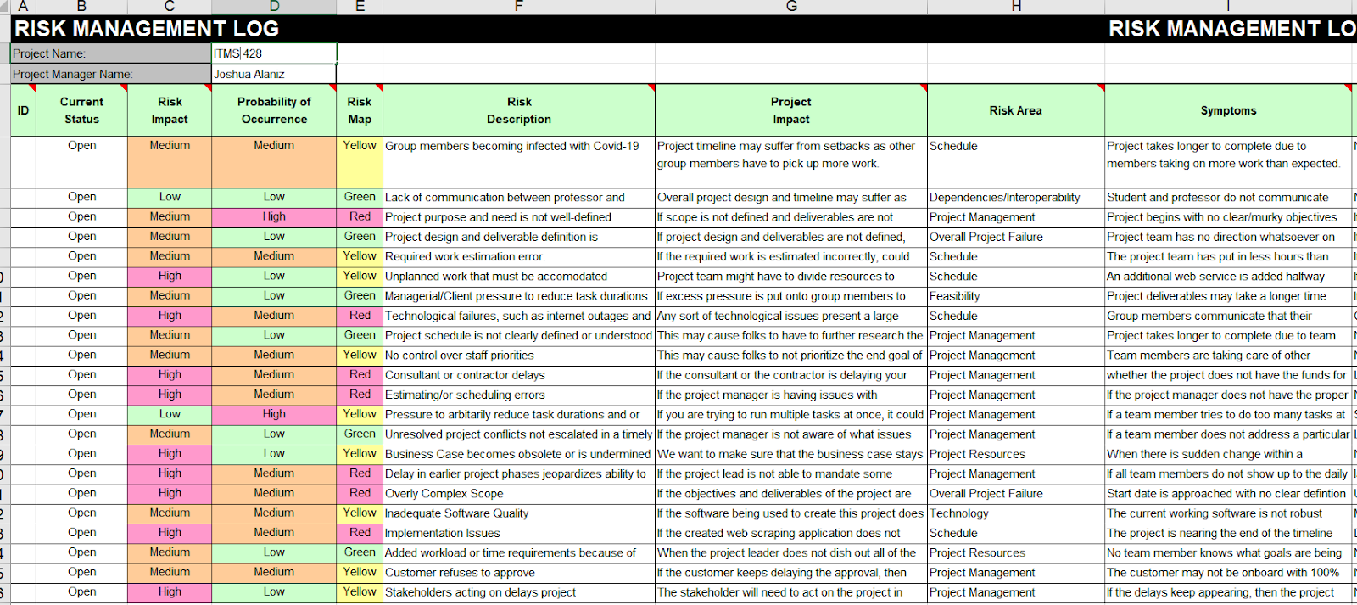

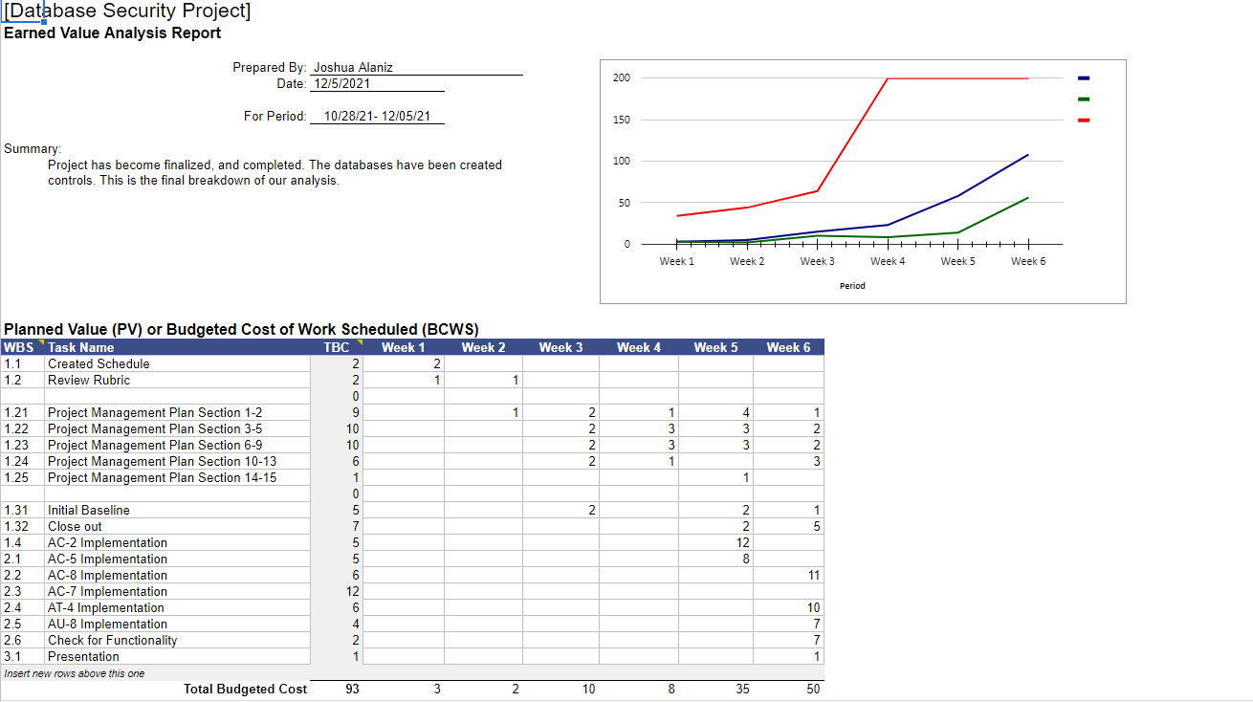

---------------------------------------------------------------------------------------------------------------------
Scope Statement
---------------------------------------------------------------------------------------------------------------------
Justification:
Dr. Maurice Dawson, a professor of Illinois Institute of Technology, has assigned a student to create a Database for their ITMS 428 Database Security final project. Dr. Dawson expects the team to design and implement controls, create a project management plan, analyze the results, create a report of the findings, and then present the findings to the professor.

Stakeholders and Key Personnel:
- Organization - Illinois Institute of Technology, Sponsor
- Staff - Dr. Maurice Dawson, Professor
- Students:
- Joshua Alaniz - Lead Project Manager
- Joshua Alaniz - Data Analyst
- Joshua Alaniz – Database Manager

Scope of Work:
Professor Maurice Dawson of ITMS 428 Database Security Technologies has the student with creating a Database as a final project. The student’s database must be contained 7 tables, and 1000+ entries, 5 users. The student is allowed to use MySQL Workbench, and MySQL. The team is expected to complete several tasks including: create a database, develop a process for implementing controls, generate a report for report analysis, and present reports and findings.
The team is expected to create a comprehensive project management plan for the project. The project plan must include detailed documentation and planning. Once the project plan and Database is completed, the team is expected to present to the professor. The presentation must include a live demonstration of the database.
The purpose of this project is to create a secure database that meet industry standards. Then, present those findings to the professor.

Project Goals and Objectives:
The goal of this project is to create a secure database that meet industry standards. Then, present those findings to the professor by 12/5/2021.

Project Characteristics and Requirements:
- Create a concept
- Develop a database of required specifications
- Implement controls
- Generate a report
- Present your findings

Project User Acceptance Criteria:
- Create a functional Database that meets requirements before 12/5/2021
- Submit the project management plan to the professor by 12/5/2021

Summary of Project Deliverables:
- Project Management Plan
- Project Charter
- Communication Plan
- Risk Management log
- Cost Evaluation
- Logical Design
- Database
- Database Controls
- Presentation

Project Concept:
Authors: Joshua Alaniz
Concept:
  - Creation of database that meets criteria
  - Implementation of NIST Controls
  - Verify the functionality of the database

Deliverables:
● Project Managers
○ ITM Plan
○ Risk Management Log
○ Cost Evaluation
● Developers
○ Database program
● Analysis Report
○ Analysis Report
● Presentation
○ Presentation (PowerPoint & Video)

-----------------------------------------------------------------------------------------------------------------
Software Configuration Management (SCM) Plan:
-----------------------------------------------------------------------------------------------------------------
Date: 12/05/2021
Authors: Joshua Alaniz
The code for the Database Security was published to Joshua Alaniz’s Github. It can be accessed through this link: https://github.com/jalaniz-sys/Database-Security-ITMS-428
Description: The overall objective of a Software Configuration Management Plan is to document and inform project stakeholders about Configuration Management with the project, what Configuration Management tools will be used, and how they will be applied by the project to promote success. The Configuration Management Plan will define the project’s structures and methods.
Development:
The database created was able to have safeguards for internal and external affairs.
Measurements:
Database:
  - The date period for pulling the data should be 12/01/2021 - 12/6/2021.
  - Database was able to meet all the specified criteria
Execution:
The database successfully was able to hold all the data it was designated to hold, as well as remaining compliant under NIST Framework.

Approval Signatures

Project Plan Approval
The signatures below indicate that the undersigned:
- Have reviewed the Project Plan.
- Have formally voiced applicable concerns to the PM.
- Concur that the Project Plan accurately represents their expectations and conditions required for the project.
- Are committed to providing the required resources.
- Are unaware of undocumented conditions that prevent the success of this project.

REVIEW DATE: 12/5/2021
SCRIBE: Joshua Alaniz

Signed: Electronic Signature
_________________________________________________________________________
Joshua Alaniz 12/05/2021

Signed: _________________________________________________________________________
Professor Dawson 12/05/2021

